

**Snapvault Design in xMarkets**

**Synopsis:** The document presents a high level plan for xMarkets backup design utilizing Netapp Snapvaults

**Segment:** Infrastructure as a Service – Storage

**Authors:** Dhiman Chakraborty

**Contributors:**

**Document Version:** V1.4

**Date:** 11th September 2014

Document Status: Final (revision)

**CONFIDENTIAL INFORMATION**

This document contains information proprietary to Thomson Reuters and may not be reproduced, disclosed or used in whole or part without express permission of Thomson Reuters.

© Thomson Reuters 2014

Contents

1 Introduction 3

1.1 Management Summary 3

1.2 Document Scope 3

1.3 Assumptions 3

1.4 Risks 3

1.5 References 3

1.6 Change History 3

1.7 Distribution List 4

1.8 Glossary 4

2 Findings 5

3 Backup and Restore 6

3.1 Additional Configurations 6

3.2 Backup 6

3.2.1 CIFS Backup 6

3.2.2 NFS Backup 6

3.3 Restore 8

3.3.1 CIFS restores 8

3.3.2 NFS restores 8

3.4 Backup definitions 8

3.5 Backup grouping 8

3.5.1 Backup grouping limitations 9

3.6 Types of backup vFilers 9

3.7 Naming standard 9

3.7.1 For vFiler name 9

3.7.2 For volume/qtree name 10

# Introduction

## Management Summary

The document entails a high level design of a proposed backup solution in xMarkets using Netapp snapvaults.

## Document Scope

Backup design proposal utilizing Netapp Snapvault in xMarkets for Netapp controllers.

This backup design does not contain a plan for iSCSI yet. Only services catered are CIFS and NFS.

## Assumptions

* It is assumed that the audience is conversant with Netapp technologies and specifically on Netapp Snapvaults
* All the service, core and backup VLANs are tagged so there is no issue with inter VLAN communication.
* All the Core, Service and Backup or replication VLANs participating in the network are tagged.

## Risks

* We need to procure additional IPs each for the backup environments per production CIFS vfiler.
* There will be additional IP requirements for a few NFS vFiler.

## References

|  |  |  |  |  |
| --- | --- | --- | --- | --- |
|  | **Document** | **Version** | **Date** | **Author** |
| 1 |  |  |  |  |

## Change History

|  |  |  |  |
| --- | --- | --- | --- |
| **Ver** | **Date** | **Author** | **Key Changes** |
| 1.0 | 10th Dec 2013 | Dhiman Chakraborty | Initial draft for comments |
| 1.1 | 12th Dec 2013 | Dhiman Chakraborty | Modified the volume naming standards |
| 1.2 | 13th Dec 2013 | Dhiman Chakraborty | Modified the restore proposal |
| 1.3 | 16th Dec 2013 | Dhiman Chakraborty | New additions in the backup and restore section |
| 1.4 | 11th Sept 2014 | Dhiman Chakraborty | Added the backup grouping scenarios and the backup vFiler configuration criterion. |

## 

## Distribution List

|  |  |
| --- | --- |
| **Name** | **Role** |
| DCO-CPS-STO-DE-NAS | Reviewer |

## 

## Glossary

|  |  |
| --- | --- |
| **Term** | **Definition** |
| NAS | Network Attached Storage |
| FS | File System |
| VI | Virtual Infrastructure |
|  |  |

# Findings

xMarkets servers multiple Customers on multiple different individual subnets. The networks are, at a high level segregated into two different segments – Core and Service

The Core serves Customers, Infrastructure resources from a secure network whereas in the Service segment, the Customers are served infrastructure resources on a DMZ network, mostly public with less security but nevertheless, non-compromised.

Apart from this segmentation, each Customer is hosting their server data on both Service and Core segments. Each of these segments are catered from individual VLANs that are tagged (Layer3). They are catered from different vFilers from Netapp storage.

# Backup and Restore

The backup is currently catered by TSM. The proposal is to cater all the backups from production Netapp storage to Netapp tertiary storage utilizing Snapvault. Restores are being rendered by the Customers directly without storage team’s intervention.

## Additional Configurations

Each CIFS vFiler in production participates in a different AD based up on the application and access the fenced for that application only and there is no single domain or flat network. This makes the restores a bit challenging since Customers perform their own restores. It is required to procure an IP for each of the CIFS production VLANs on the backup controller for restore purposes. Without this the Customer backup vfilers will not be able to register to their own DC.

Additionally when a storage engineer configures a backup for Customer, they need to have similar export/share definitions matching production storage unit. Only then Customer can access this share or FS.

The Customer will need to be notified of these exports (CIFS shares or NFS exports) once the backup configuration is complete.

## Backup

The backup will run via existing core VLAN meant for replication; if there are too many complications for running backup and replication from the same VLAN, there will be another dedicated VLAN only for backups from primary to Snapvault cpontroller. . All the core and service storage units from production will be backed up via this VLAN (VLAN ID 199 & 200) to vFiler0 on the backup controller.

### CIFS Backup

Since each of the Production CIFS vFilers are registered to a Domain Controller in their own domain, we need to maintain similar backup vFiler resources in the backup environment as well i.e. IPs from the VLAN and the DNS domain registered.

This will enable Customers to login to the backup controller are perform their own backups.

### NFS Backup

Core and Service VLAN we will have a separate “common” vFiler for each. Similarly for Core and Service VLANs catering Virtual Infrastructure, there will be one vFiler for Core and Service VLANs.

The idea is to keep Virtual Infrastructure in a separate vFiler environment – each for Core and Service.

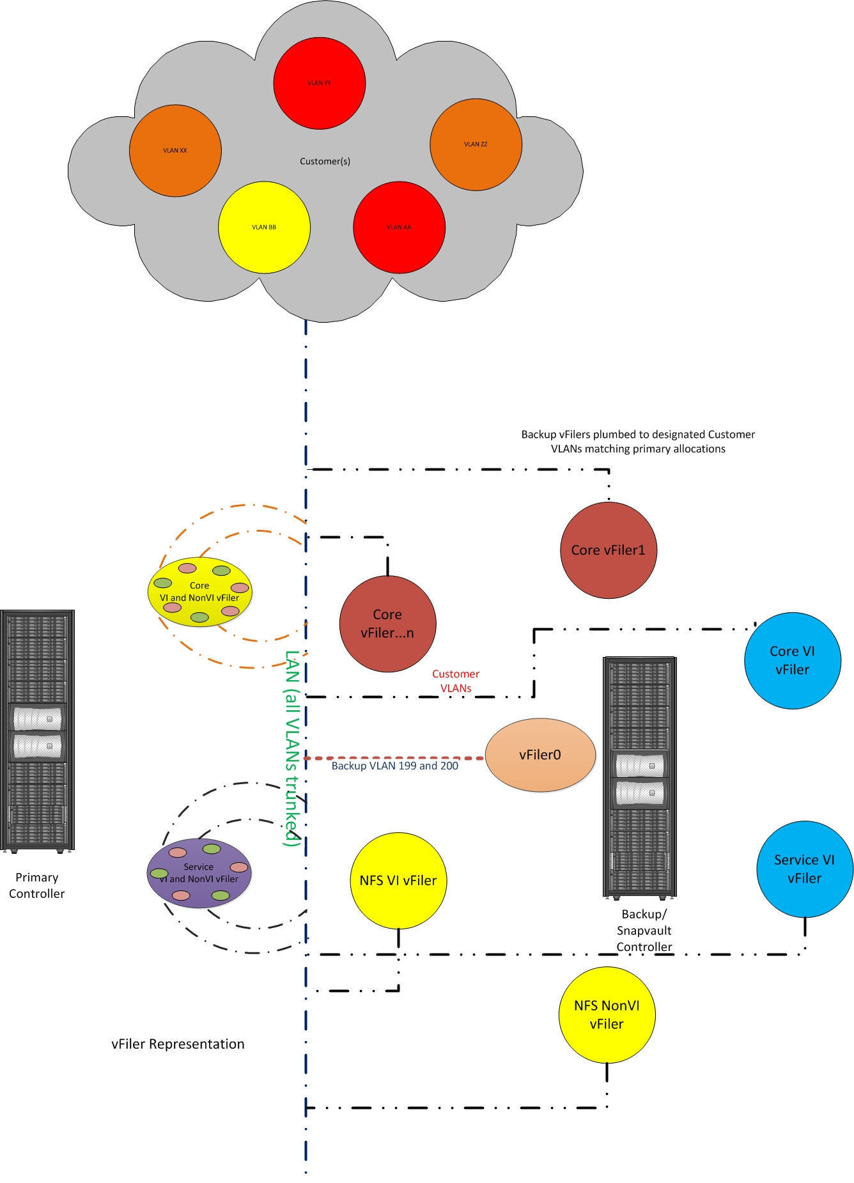

1. Figure 1 Backup proposal representation in xMarkets

## Restore

### CIFS restores

The CIFS restores will be rendered from the same VLAN the Customer is already in. When is restore is required, the Customer will access the share from the backup vfiler and perform restore.

### NFS restores

NFS restores will be catered from the common vFiler for each type of service, notably:

* Common NFS vFiler for Service VLAN including VI infrastructure
* Common NFS vFiler for Core VLAN including VI infrastructure
* The export definitions on the Snapvault vfilers will need to match the definitions from primary storage environment, otherwise there will be issues with the restore.

When a restore is required, the Customer will mount the volume/qtree based on export definition on their server and perform restore.

## Backup definitions

* Unless otherwise specified, all the production volumes with a retention definitions less than or equal to 1month (30 days) will have a retention level of 30 days on tertiary storage.
* Stack all volumes VM volumes to a backup volume as qtrees.
* Stack Non VM primary volumes to a common backup volume as qtrees.
* Each backup volume should not contain more than 7 qtrees (or) the snaps should not be more than 210 snaps per backup volume; whichever is applicable.
* If the primary volume backup definition spans more than 1 month, then volume retention based on that definition. This is purely on exception basis!
* All the backup storage units will be created with 1.5x compared to its production space.

## Backup grouping

As in most cases, the backup grouping will be first defined based on the service offering:

1. Production vFiler running CIFS and NFS
2. Production vFiler running only CIFS
3. Production vFiler running only NFS

### Backup grouping limitations

The whole idea is not to go beyond 210 snapshots. The entire decision to keep as many backup units per backup volume is determined by the following calculation.

* For 45 day backup – backup vol can retain (210/45 ) ~ 5 vols as qtrees in backup vol.
* For 30 day backup backup vol can retain (210/30 ) ~ 7 vols as qtrees in backup vol.
* For 14 day backup backup vol can retain (210/14 ) ~ 15 vols as qtrees in backup vol.
* For 7 day backup backup vol can retain (210/7 ) ~ 15 vols as qtrees in backup vol. (In this case we can retain 30 prod vols, but we have kept an upper limit of 15 qtrees per

**Note:** It is to be noted that the backup qtrees per volume should be contained upto 16. This is to support the automation of backups that is being orchestrated by the delivery team(s).

## Types of backup vFilers

One of the major wins from this backup plan is to further consolidate the backup vfilers in a controllers without hampering the restore/backup plan. With the current limitations of 7mode, we can stack upto 65 vFilers in a controller. The proposal limits the number of backup vFiler creation based on the services they render and the network cell they belong. The following is proposed for creating backup vFilers by types:



## Naming standard

### For vFiler name

**CIFS vFilers**

Any vFiler servicing CIFS and/or servicing both CIFS and NFS will have a dedicated backup vFiler with an IP from the same Production VLAN.

|  |  |
| --- | --- |
| **Production vFiler** | **Backup vFiler** |
| sg1p-aaafs01 | sg1p-aaafs01-sv |
| dtcp-cpafs01 | dtcp-cpafs01-sv |
| dtcp-cpafs02 | dtcp-cpafs02-sv |

**NFS vFilers**

* There will be a common backup vFiler for NFS production vFilers; albeit separate for Service and Core.
* In addition, the VI vFilers will also have a common backup vFiler, albeit separate for Service and Core.

|  |  |
| --- | --- |
| **Network Type** | **Backup vFiler** |
| Core | sg1p-snfs-sv |
| Service | sg1p-cnfs-sv |
| Core for VI | sg1p-vicnfs-sv |
| Service for VI | sg1p-visnfs-sv |

### For volume/qtree name

The volume name and qtree name would be as follows:

**sv_<30>_<controller_name>_vol001/<production_vol_name>**

Where,

**sv** - Prefix for the snapvault relationship

**<30>** - Retention definition. It could be 30 or 14 based on the definitions.

**<controller_name>** - Controller Name

**vol001** - Volume name with the count

**<production_vol_name>** - Backup qtree name same as the production volume name.

**For Virtual Infrastructure**

**sv_<30>_infra_<controller_name>_vol001/<production_vol_name>**

Where,

**sv** - Prefix for the snapvault relationship

**<30>** - Retention definition. It could be 30 or 14 based on the definitions.

**Infra** - Tag given for infra volumes

**<controller_name>** - Controller Name

**vol001** - Volume name with the count

**<production_vol_name>** - Backup qtree name same as the production volume name.